Name_________________________________ Period _____________ Date ________________



**Lesson 3: Avoiding the Dizzies**

Just because an object can lift off the ground does *not* mean that stable flight will occur. The correct combination of propellers is needed to keep the object from spinning wildly, like a carnival ride. Can you find the best propeller combination that provides stable flight?

**Doing the Science**

1. Start the Dronopter Simulation by clicking on the “Sim” tab.

2. Select and drag the aluminum frame to the center of the table.

3. Using *only* either the 80/8/CW or 80/8/CCW motors, place the motors in the positions stated in Figure 1 and Table 1.

4. Click the “Test” button to test each motor combination and position.

5. On the next screen, drag the red circular joystick handle to control the thrust. Note and record in Table 1 whether the dronopter had stable flight or not. Stable flight is defined as flight you can control.

6. Select the “Build” button to return to the first screen.

7. Repeat steps 3–6 until all motor positions have been tested.

Figure 1.

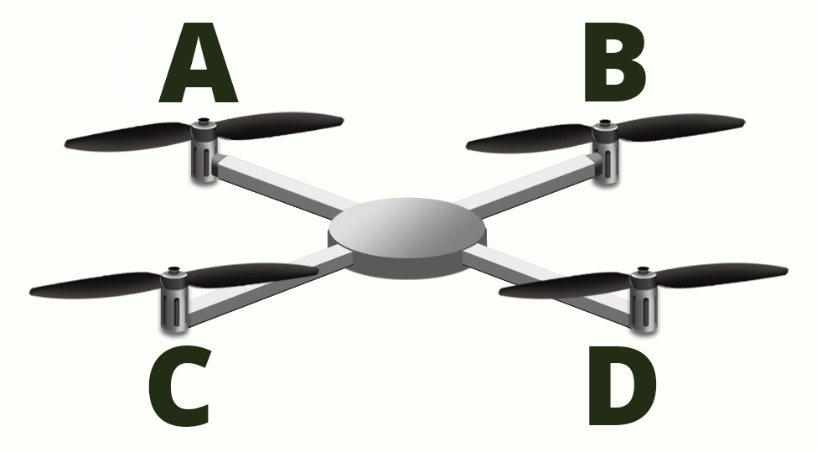

Table 1.

|  |  |  |  |  |  |
| --- | --- | --- | --- | --- | --- |
| **Exp.** | **Position A** | **Position B** | **Position C** | **Position D** | **Flight Result** |
| 1 | CW | CW | CW | CCW |  |
| 2 | CW | CW | CCW | CCW |  |
| 3 | CW | CCW | CCW | CW |  |
| 4 | CW | CW | CCW | CCW |  |
| 5 | CW | CCW | CW | CCW |  |
| 6 | CCW | CW | CCW | CCW |  |
| 7 | CCW | CCW | CW | CCW |  |
| 8 | CCW | CW | CW | CCW |  |
| 9 | CCW | CCW | CCW | CW |  |

**Do You Understand?**

1. Which experiment(s) and motor position(s) gave the dronopter stable flight?

2. Which experiment(s) and motor position(s) did *not* result in stable flight?

3. What generalization can you make about the position of the propellers to achieve stable flight in your dronopter?

4. While the dronopter has four motors with propellers spinning in a specific way to achieve stable flight, how does a helicopter with only one main propeller for lift have stable flight?